Sorter Timeline: MSF in Mozambique 1984 - 2024

1984

MSF38821

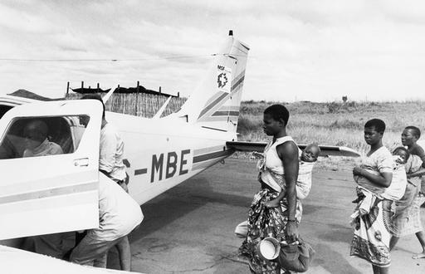

Once a week MSF came by plane to bring medical supplies and to pick up patients in Cuamba district. October 1989. ©B Eijgenhuijsen

Médecins Sans Frontières/Doctors Without Borders (MSF) becomes one of the first medical humanitarian organization to operate in all provinces of Mozambique during the armed conflict.

1993 – 2000

MSF38840

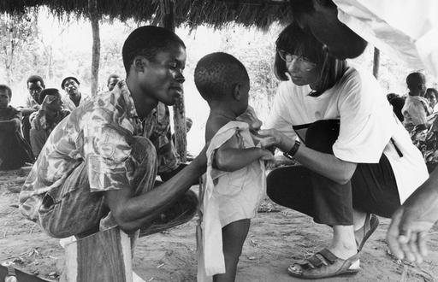

[Caption] MSF nurse during a nutrition survey in the Niassa region. January 1994. ©Peter Slavenburg

MSF supports post-conflict health system reconstruction, provides response to cholera epidemics and floods in Maputo, Gaza, and Limpopo in 2000.

2001

MSF starts working on HIV/AIDS.

2003

In collaboration with the Ministry of Health of Mozambique (MISAU), MSF starts treating patients with antiretroviral therapies in Maputo and Tete.

2004

MSF carries out the first cholera vaccination campaign in the country, in collaboration with the Ministry of Health of Mozambique, in Beira.

2008

MSF142574

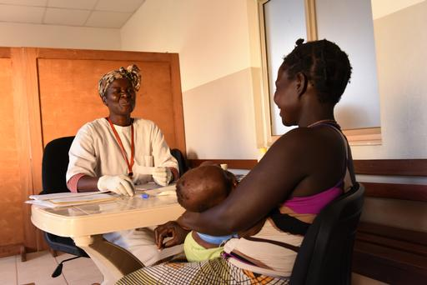

[Caption] Francisca Vasco, counselor in a clinic of Tete, doing voluntary counseling and testing for HIV and other sexually transmitted infections. January 2014. © Felco Calderin

MSF launches the Community Support and Adherence Group for people living with HIV in Tete, to broaden the access to antiretroviral treatment, prioritizing treatment adherence and minimizing patient travel distances for medication and consultations.

2013

MSF131889

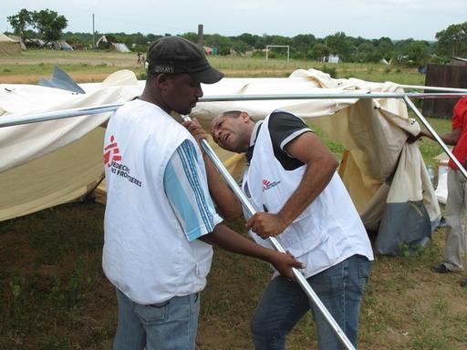

MSF team is installing a tent for a temporary health post in Chinhacanine, Gaza province. February 2013. ©MSF

MSF starts, in Maputo, a project to provide care against drug-resistant tuberculosis. This year, we also responded to the flooding in Gaza province.

2014

MSF142600

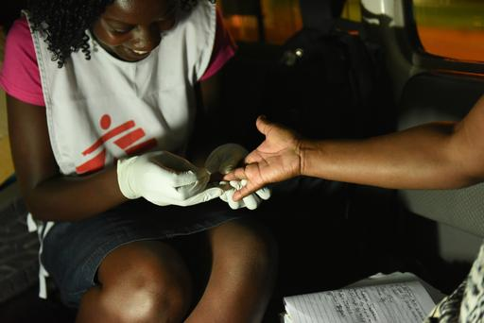

[caption] MSF counselor conducts an HIV pre-test and counseling inside the MSF car at a remote parking area outside Beira City. January 2014. © Felco Calderin

In the cities of Beira and Tete, MSF offers HIV treatment and prevention care for to at-risk populations, including sex workers, men who have sex with men and transgender women.

2016

MSF171610

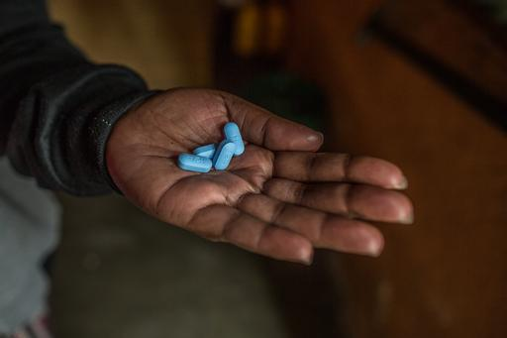

[caption] Pre-Exposure Prophylaxis (PreP) that prevents HIV infection amongst HIV negative women. July 2016. © Morgana Wingard

MSF starts treating viral hepatitis in Mozambique and initiates the provision of oral Pre-Exposure Prophylaxis (PrEP) for HIV prevention in at-risk populations in Beira and Tete.

2016-2017

Assistance in mobile clinics to offer health services in the camp for displaced people in Espungabera and Manica.

**2017**

MSF in collaboration with the Ministry of Health of Mozambique, responds to cholera through a vaccination campaign in Tete.

2018

MSB104835

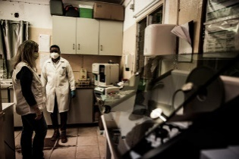

[caption] Natalia Tamayo (left), the coordinator of the harm reduction programme for drug users, at the laboratory. June 2021. ©Oscar Corral

MSF starts the harm reduction programme for people who use drugs, with the opening of a community centre in Maputo.

2019

MSF started to work in Cabo Delgado in 2019, delivering healthcare to people displaced by the conflict or returning to their homes. In this year, MSF also responded to cyclones Idai and Kenneth, providing logistical and technical support to the Ministry of Health of Mozambique in the cholera vaccination campaign, which reached 900,000 people, and in the treatment of the disease. In addition, MSF’s response focused on water treatment, disinfection of contaminated water sources and well cleaning.

2020

MSF324558

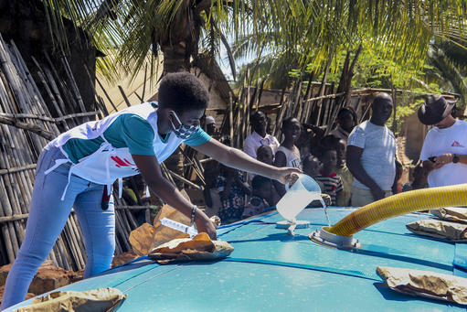

[Caption] MSF staff member manages water treatment at a distribution site in the Natiti neighborhood of Pemba. April 2020. ©MSF

MSF provides primary health care, water, and sanitation for internally displaced people in Cabo Delgado province. We also started the opioid substitution therapy (Methadone) programme for people who use drugs in Maputo.

2021

MSB114024

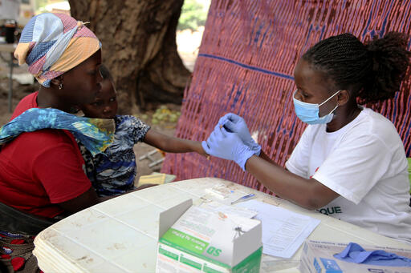

[Caption] Nurse Benvinda screens children accompanied by their mother and elder sister at an MSF mobile clinic in the province of Cabo Delgado. December 2021. © Igor Barbero/MSF

MSF supports the Ministry of Health in the COVID-19 response in Maputo, Beira, and Pemba. MSF has expanded its presence in Cabo Delgado and continues to support the conflict-displaced population with health services, mental health and water and sanitation.

2022

MSB163243

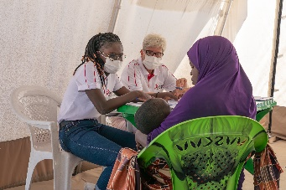

[Caption] MSF medical staff carry out consultations with patients in Nampula Province. June 2023. ©MSF/Pierre-Yves Bernard

MSF begins collaboration with the Ministry of Health of Mozambique, for the province of Nampula, focusing on neglected tropical diseases, vector-borne diseases, as well as emergency preparedness such as cholera and natural disasters.

2023

MSF responded to the largest cholera outbreak in the last 8 years in the country, Quelimane, Zambezia.

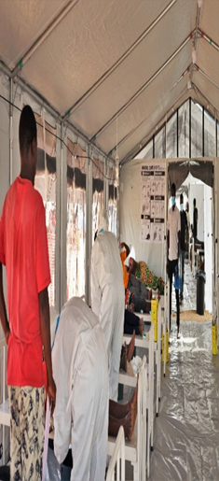

2024

MSF has been in Mozambique for 40 years, responding to emergencies including disease outbreaks, providing care to people with advanced HIV, while also working in the conflict-ridden Cabo-Delgado province.

Intervention in Nampula, Mozambique following a boat accident that killed nearly 100 people in recent weeks. They died after a makeshift ferry they had bordered trying to flee the mainland due to panic over misinformation about cholera outbreak sunk. At least 55 children died, and some people lost their entire families. MSF has provided psychological first aid to the families of the victims. Our team shared the experiences of the community after the shipwreck and how they are struggling to cope with this tragic incident.

